**DAILY ONLINE ACTIVITIES SUMMARY**

|  |  |  |  |  |  |  |  |
| --- | --- | --- | --- | --- | --- | --- | --- |
| **Date:** | **22/05/2020** | | | | **Name:** | **Churashma** | |
| **Sem & Sec** | **4th SEM 'A' Section** | | | | **USN:** | **4AL18CS019** | |
| **Online Test Summary** | | | | | | | |
| **Subject** | | **Operating system** | | | | | |
| **Max. Marks** | | **30** | | **Score** | | **17** | |
| **Certification Course Summary** | | | | | | | |
| **Course** | **Introduction to digital marketing** | | | | | | |
| **Certificate Provider** | | | **greatlearning academy** | **Duration** | | | **1.5 hours** |
| **Coding Challenges** | | | | | | | |
| **Problem statement 1:Write a C or Java program to implement round robin type of process scheduling.**  **Problem statement 2**:**Write a C Program to implement various operations on Singly Linked List Stack.** | | | | | | | |
| **Status: completed** | | | | | | | |
| **Uploaded the report in Github** | | | | **yes** | | | |
| **If yes Repository name** | | | | **https://github.com/Churashma/Lockdown-coding** | | | |
| **Uploaded the report in slack** | | | | **yes** | | | |

**ONLINE TEST DETAILS:** OS test was scheduled from 09:15 am t0 09:50am .The portion for the IA was 1st module there were 30 questions and the time assigned was 40 minutes the questions were mcq type.

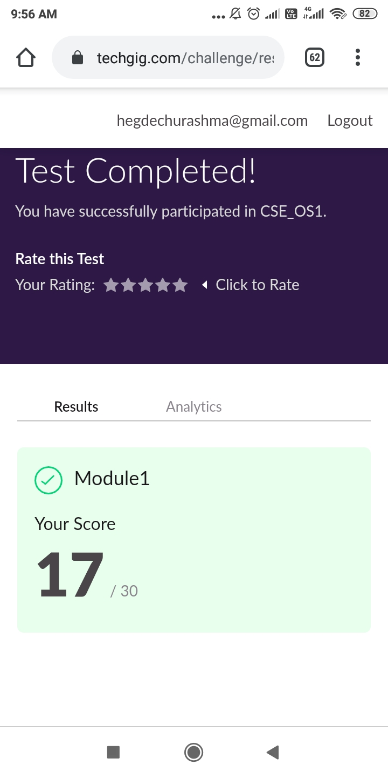

**CERTIFICATION COURSE DETAILS:** Today I studied about Facebook marketing. It involves understanding the goals of the customer and partnering with them to overcome challenges. One of the best ways to do this is to be available where they already spend their time. One reason why Facebook will be prioritizing posts from family and friends over public content from pages is that they believe a person to person connection is more valuable than person to page connection. And I also studied about Purpose of using Facebook as marketing channel.There is no denying that Facebook is here to stay. It’s amazing to think that what started as a simple way to stay in touch with friends has turned into a platform that connects people and brands all across the world.

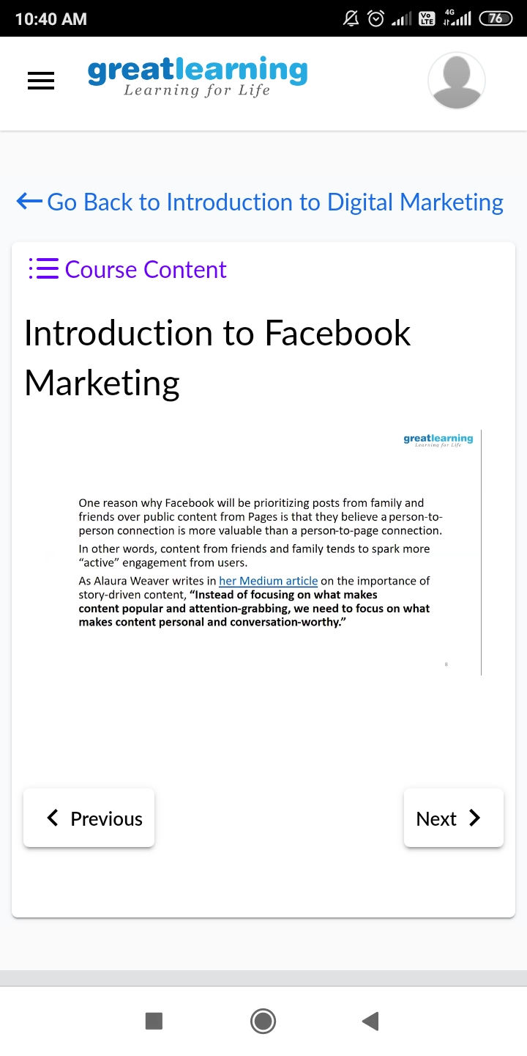

**CODING CHALLENGES DETAILS**:

**Problem statement 1: Write a C or Java program to implement round robin type of process scheduling.**

**Input: Process with burst time, arrival time and specify the time quantum**

**Output: Processes scheduled based on the round robin type of scheduling, with its average waiting time.**

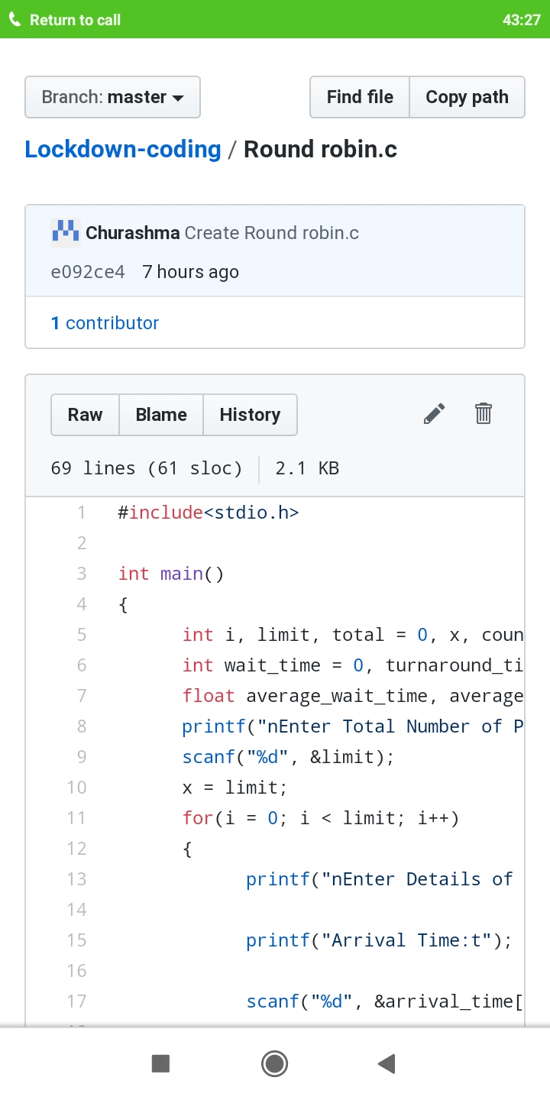

**Problem statement 2 : Write a C Program to implement various operations on Singly Linked List Stack.**

**Hint: First Create a Singly Linked List Stack with the node corresponding to First Element is the base of the stack; and its link field must be always Null.**

**When you push First Element, It is the First and it is Base of the stack. Its Link must be Null. Top pointer pointing to First. (top = First)**

**When you push any element, (No need of checking Stack full case because SLL is dynamic) Create a new node called temp using malloc function and insert the a number into Data field, and Link field must be pointing to top; and move the pointer top to point to temp.**

**When you pop, First check for stack Empty. If First == NULL, then Stack Empty. If it is not empty, The pointer temp must be pointing to top. Move the pointer top to top->link. Delete temp.**

**When you display the stack element, First Check for Stack Empty as in pop operation. If it is not empty, Display all the elements of current stack starting from top to First.**

